Roll No. and Name: 24BTM058 RICHA PATEL
Course Code and Name: 3CS502ME24 OPEN SOURCE TECHNOLOGIES
Practical No: 5
AIM: Set up a Django project and create a basic web application.

METHODOLOGY FOLLOWED:

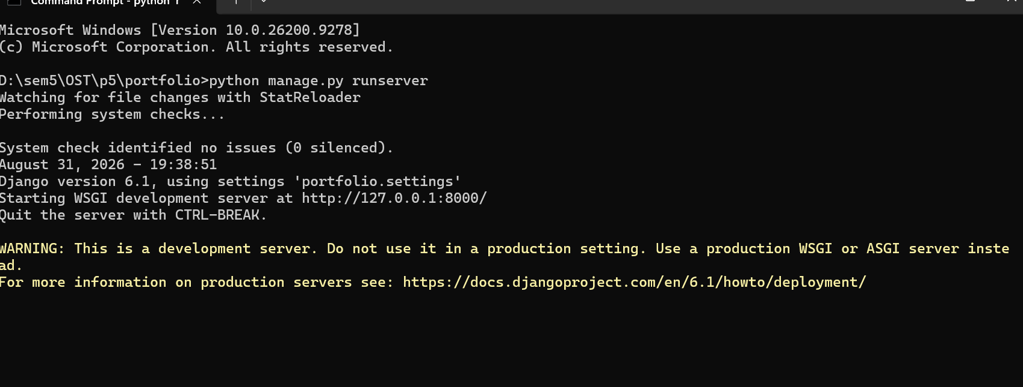
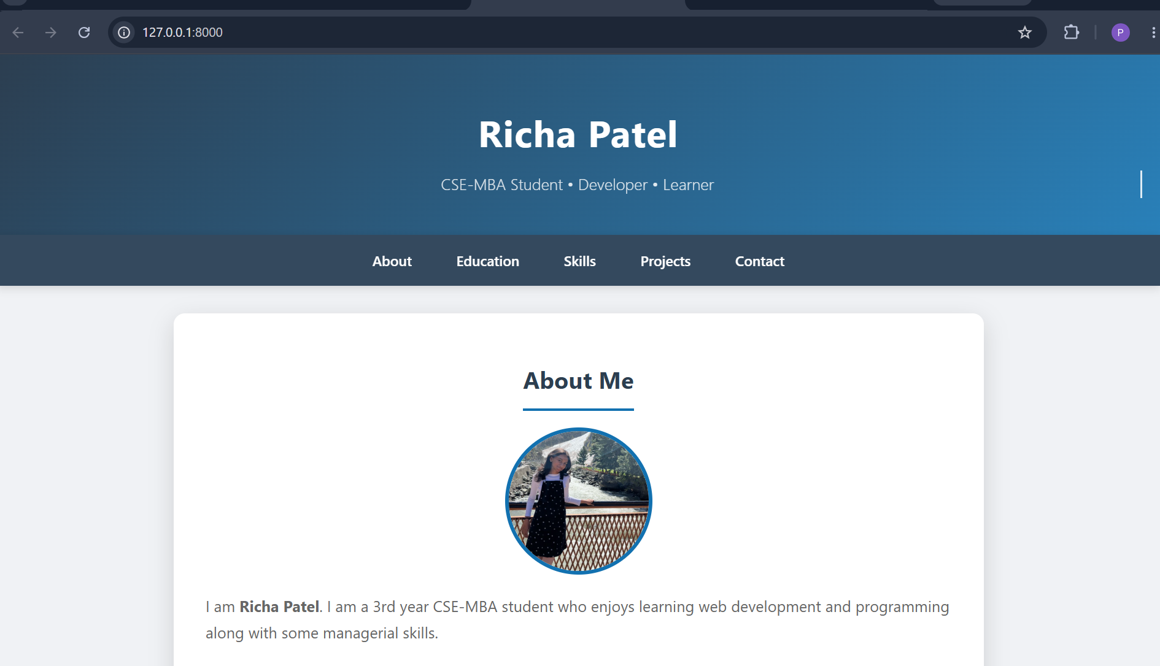
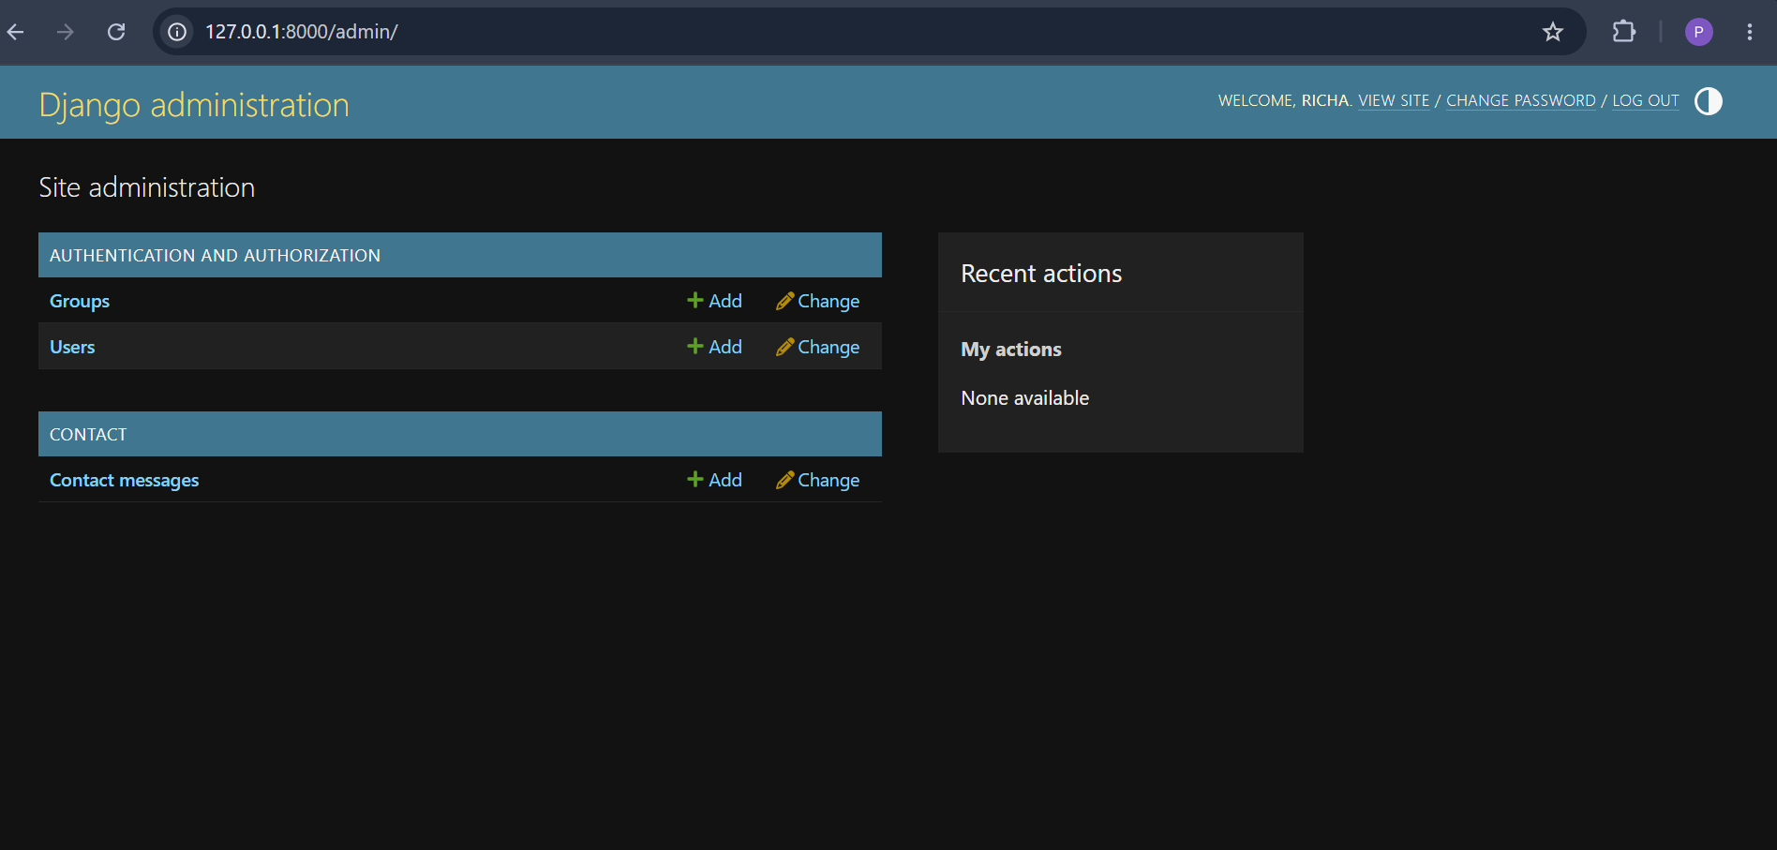
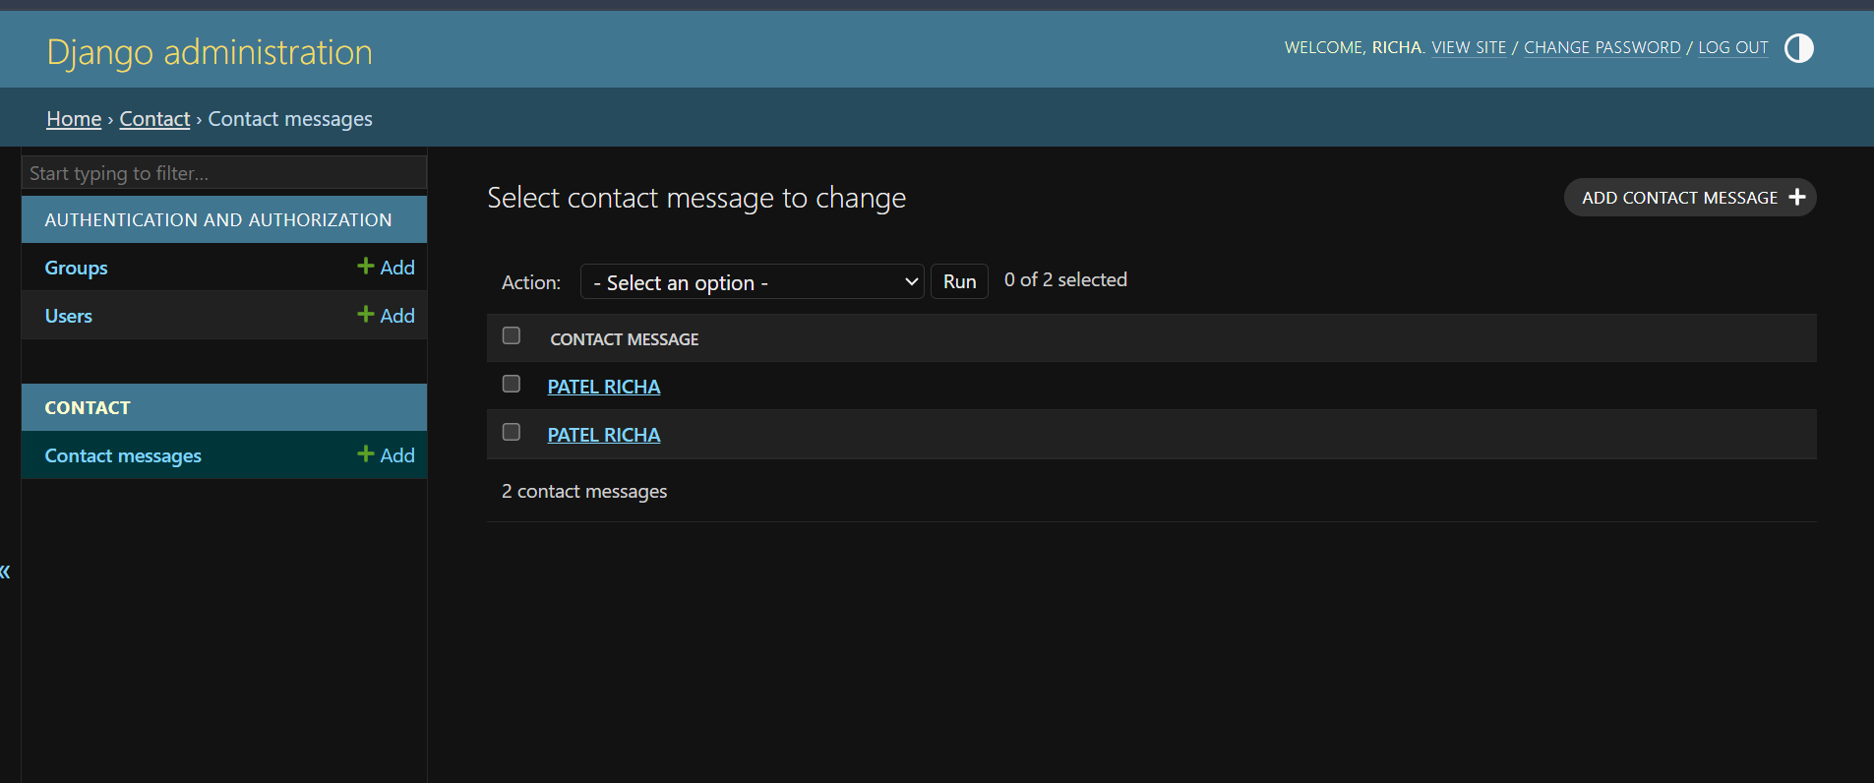

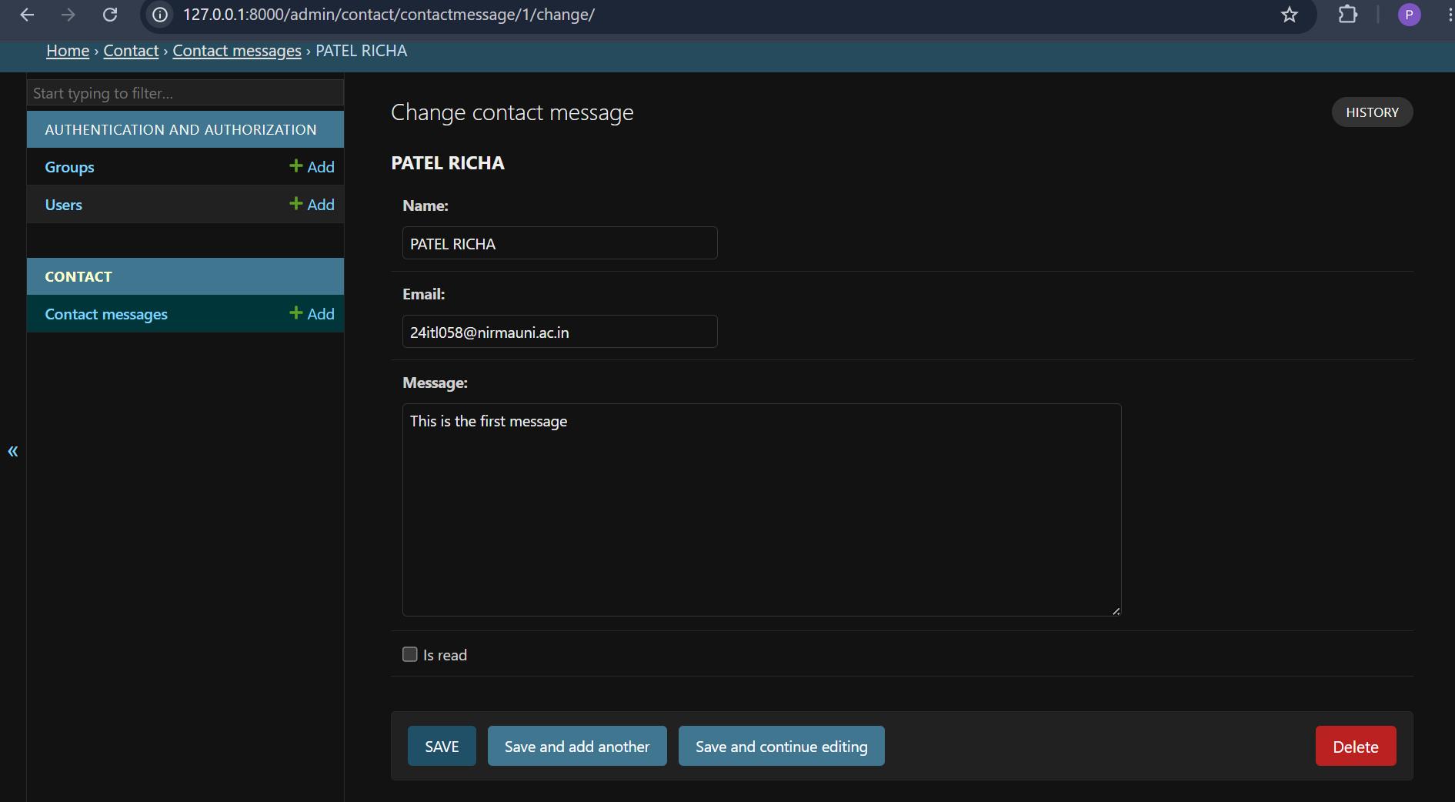
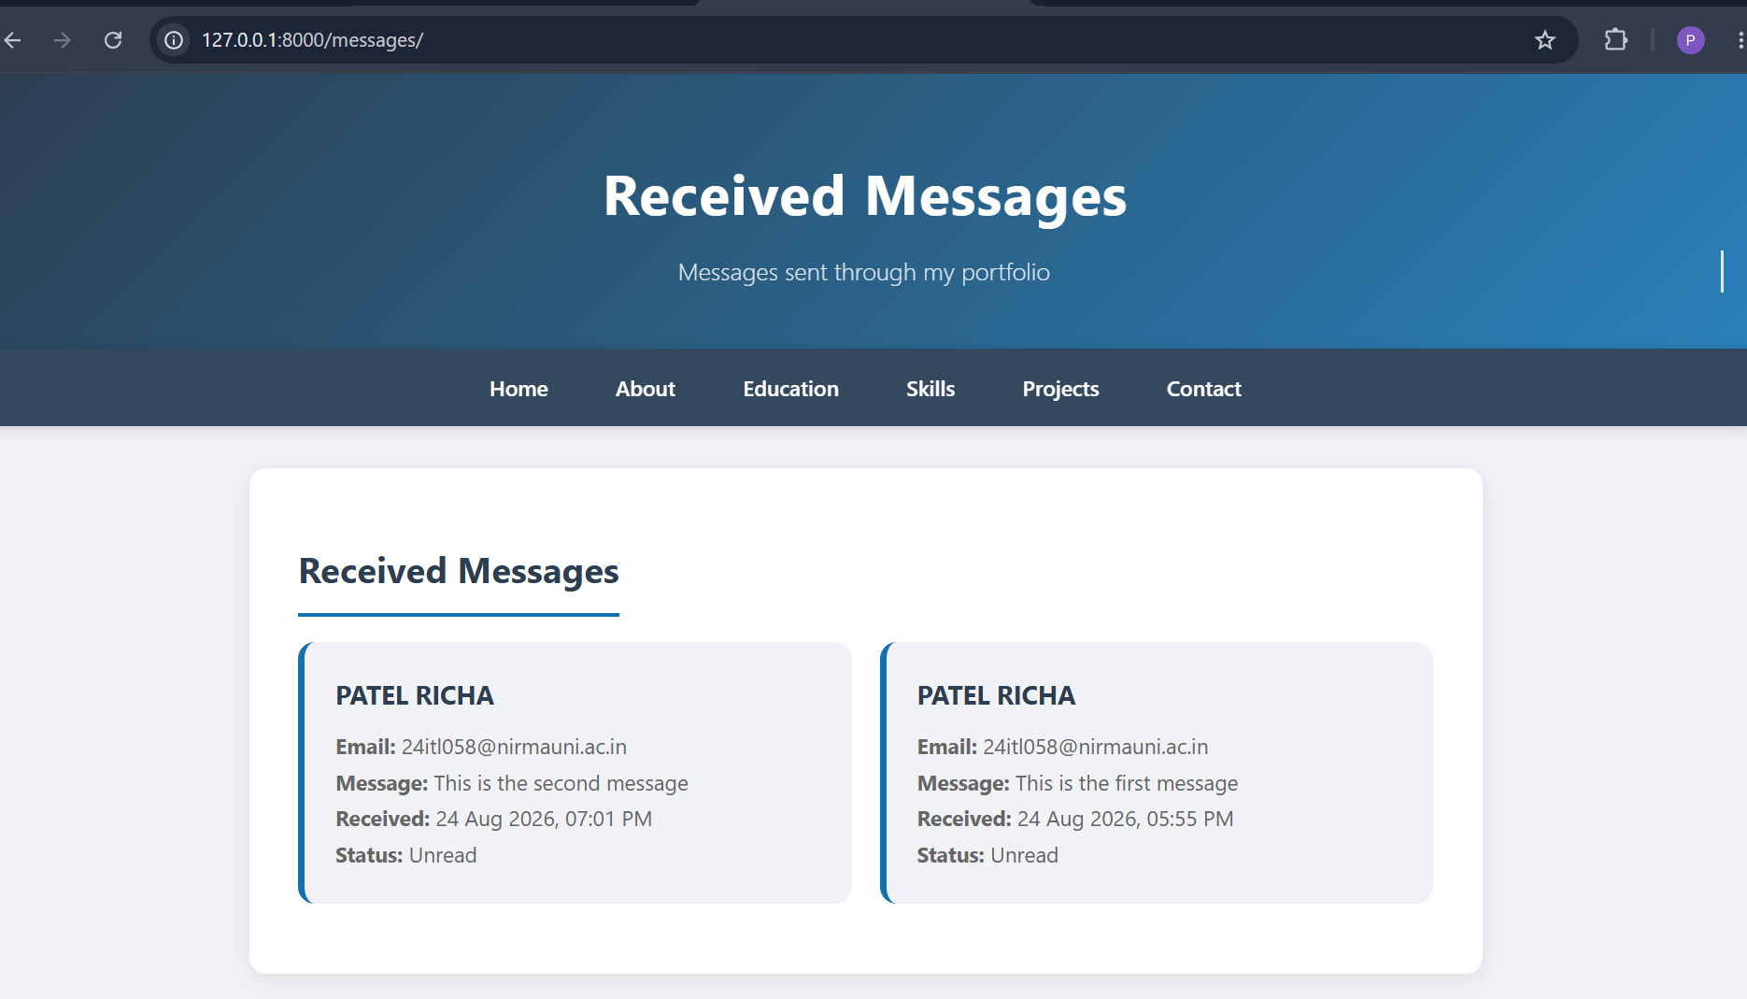

CODE:
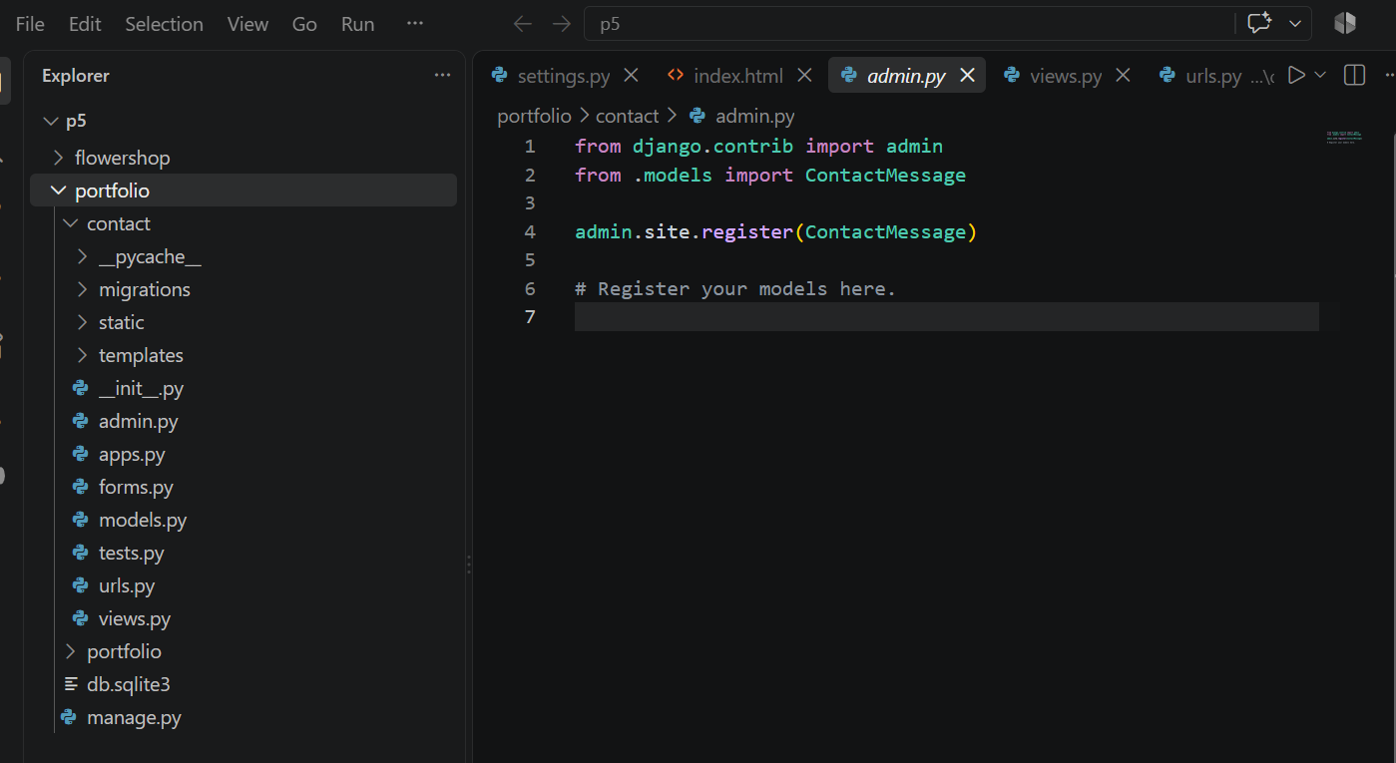
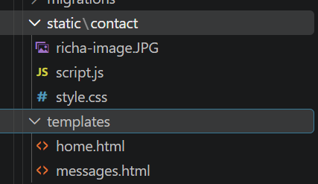
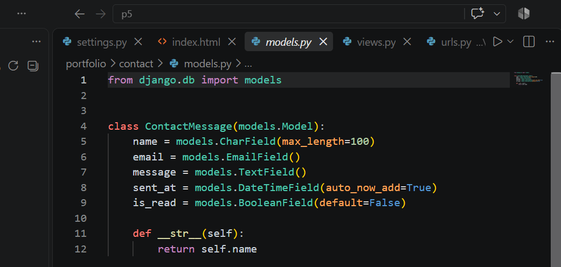

VIEWS.PY
from django.shortcuts import render, redirect

from .forms import ContactForm
from .models import ContactMessage

def home(request):

if request.method == 'POST':

form = ContactForm(request.POST)

if form.is_valid():
form.save()

return redirect('home')

else:
form = ContactForm()

return render(request, 'home.html', {
'form': form
})

def messages(request):

contact_messages = ContactMessage.objects.all().order_by('-sent_at')

return render(request, 'messages.html', {
'messages': contact_messages
})

MANAGE.PY
#!/usr/bin/env python
"""Django's command-line utility for administrative tasks."""
import os
import sys

def main():
"""Run administrative tasks."""
os.environ.setdefault('DJANGO_SETTINGS_MODULE', 'portfolio.settings')
try:
from django.core.management import execute_from_command_line
except ImportError as exc:
raise ImportError(
"Couldn't import Django. Are you sure it's installed and "
"available on your PYTHONPATH environment variable? Did you "
"forget to activate a virtual environment?"
) from exc
execute_from_command_line(sys.argv)

if __name__ == '__main__':
main()

APPS.PY
from django.apps import AppConfig

class ContactConfig(AppConfig):
name = 'contact'

SETTINGS.PY

"""
Django settings for portfolio project.

Generated by 'django-admin startproject' using Django 6.1.

For more information on this file, see
https://docs.djangoproject.com/en/6.1/topics/settings/

For the full list of settings and their values, see
https://docs.djangoproject.com/en/6.1/ref/settings/
"""

from pathlib import Path

# Build paths inside the project like this: BASE_DIR / 'subdir'.
BASE_DIR = Path(__file__).resolve().parent.parent

# Quick-start development settings - unsuitable for production
# See https://docs.djangoproject.com/en/6.1/howto/deployment/checklist/

# SECURITY WARNING: keep the secret key used in production secret!
SECRET_KEY = 'django-insecure-_q64t0yxb(!9h#p$l^u7tb=rk-hfv)t2s0*u9gdlg^w@lb5!#_'

# SECURITY WARNING: don't run with debug turned on in production!
DEBUG = True

ALLOWED_HOSTS = []

# Application definition

INSTALLED_APPS = [
'django.contrib.admin',
'django.contrib.auth',
'django.contrib.contenttypes',
'django.contrib.sessions',
'django.contrib.messages',
'django.contrib.staticfiles',
'contact',
]

MIDDLEWARE = [
'django.middleware.security.SecurityMiddleware',
'django.contrib.sessions.middleware.SessionMiddleware',
'django.middleware.common.CommonMiddleware',
'django.middleware.csrf.CsrfViewMiddleware',
'django.contrib.auth.middleware.AuthenticationMiddleware',
'django.contrib.messages.middleware.MessageMiddleware',
'django.middleware.clickjacking.XFrameOptionsMiddleware',
]

ROOT_URLCONF = 'portfolio.urls'

TEMPLATES = [
{
'BACKEND': 'django.template.backends.django.DjangoTemplates',
'DIRS': [],
'APP_DIRS': True,
'OPTIONS': {
'context_processors': [
'django.template.context_processors.request',
'django.contrib.auth.context_processors.auth',
'django.contrib.messages.context_processors.messages',
],
},
},
]

WSGI_APPLICATION = 'portfolio.wsgi.application'

# Database
# https://docs.djangoproject.com/en/6.1/ref/settings/#databases

DATABASES = {
'default': {
'ENGINE': 'django.db.backends.sqlite3',
'NAME': BASE_DIR / 'db.sqlite3',
}
}

# Password validation
# https://docs.djangoproject.com/en/6.1/ref/settings/#auth-password-validators

AUTH_PASSWORD_VALIDATORS = [
{
'NAME': 'django.contrib.auth.password_validation.UserAttributeSimilarityValidator',
},
{
'NAME': 'django.contrib.auth.password_validation.MinimumLengthValidator',
},
{
'NAME': 'django.contrib.auth.password_validation.CommonPasswordValidator',
},
{
'NAME': 'django.contrib.auth.password_validation.NumericPasswordValidator',
},
]

# Internationalization
# https://docs.djangoproject.com/en/6.1/topics/i18n/

LANGUAGE_CODE = 'en-us'

TIME_ZONE = 'UTC'

USE_I18N = True

USE_TZ = True

# Static files (CSS, JavaScript, Images)
# https://docs.djangoproject.com/en/6.1/howto/static-files/

STATIC_URL = 'static/'

# Email
# https://docs.djangoproject.com/en/6.1/topics/email/#topic-email-configuration

MAILERS = {
'default': {
'BACKEND': 'django.core.mail.backends.console.EmailBackend',
},
}

